Week 4:

Thanh Minh

Step 1:

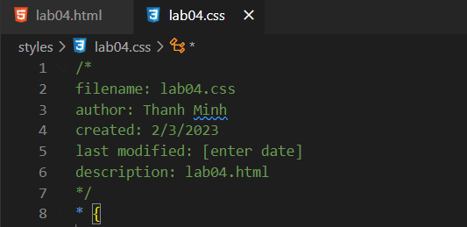

Step 2:

Step 3:

Step 4:

1. Quite green and blue

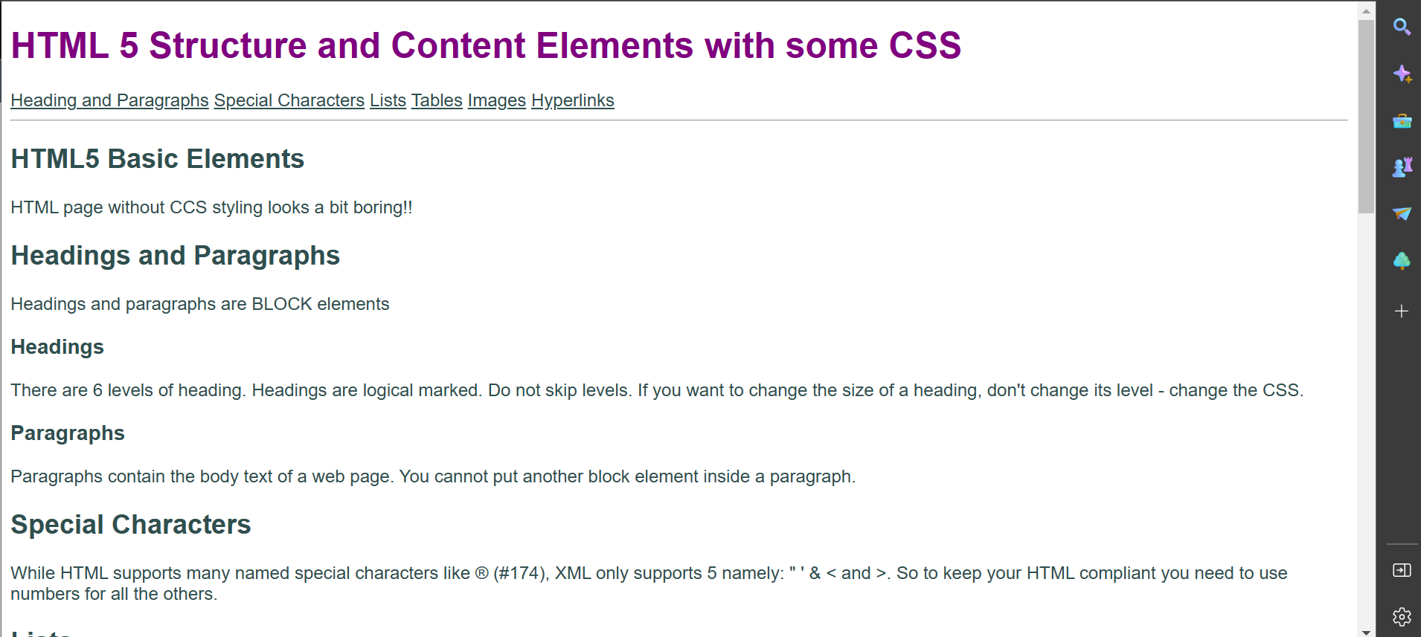

1. Text

   Description automatically generated
2. 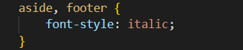
3. Text

   Description automatically generated
4. Text

   Description automatically generated
5. Text

   Description automatically generated with low confidence
6. Graphical user interface, application

   Description automatically generated
7. Graphical user interface, text

   Description automatically generated
8. Graphical user interface, text, application

   Description automatically generatedA screenshot of a computer

   Description automatically generated with medium confidence
9. Graphical user interface

   Description automatically generated with low confidence
10. None : follow the instruction of the file
11. Text

    Description automatically generated
12. Text

    Description automatically generated with medium confidence
13. Graphical user interface, text

    Description automatically generated

<https://mercury.swin.edu.au/cos10026/s103809048/lab04/lab04.html>